**SECURITY AND VOICE CONTROL HOME AUTOMATION**



**UNDER THE GUIDANCE OF :**

**Asst. Prof. Sheela Jayachandran**

**SUBMITTED BY :**

**KOTRIKE RISHIKA – 20BCE7240**

**PRATHAPANI SATWIKA – 20BCD7160**

**MEKALA POORNIMAI – 20BCD7167**

**GONUGUNTLA ROHINI – 20BCD7174**

**YENDLURI SRUTHI – 20BCE7396**

**HEMA VARSHINI DASARI – 20BCE7424**

**SOFTWARE MODULE :**

In this project we used proteus, Arduino IDE and android application to control the components (Home appliances) present inside the circuit of proteus through Bluetooth module.

**SOFTWARE CODE :**

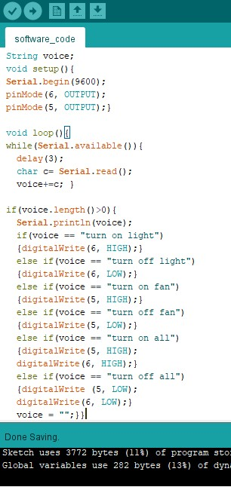

**ANDROID APP FOR SOFTWARE AND HARDWARE:**

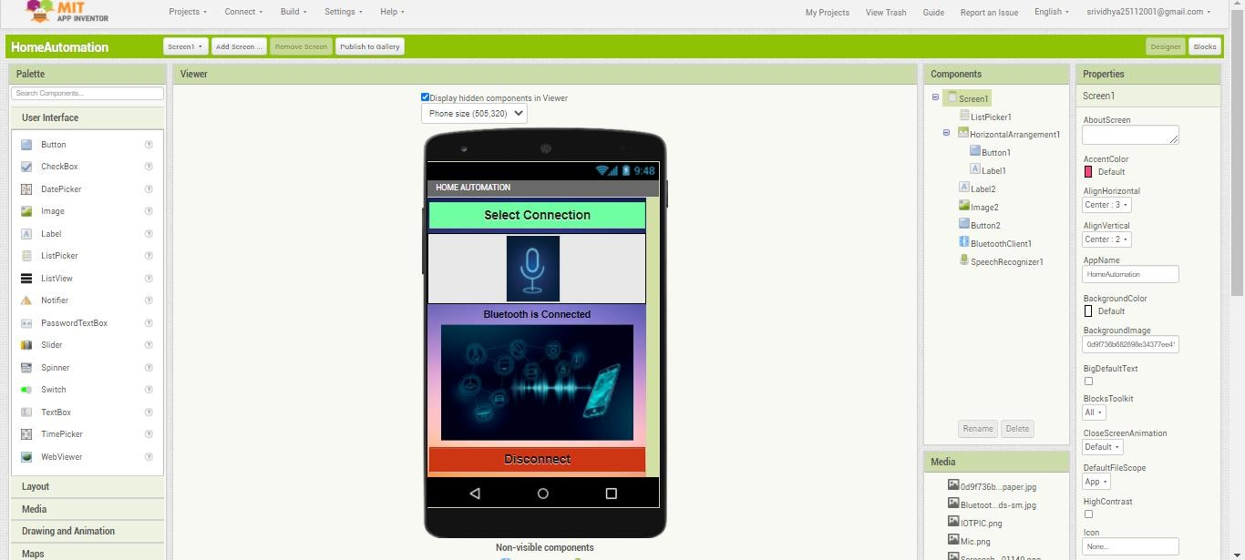

**CODE BLOCKS FOR THE APP:**

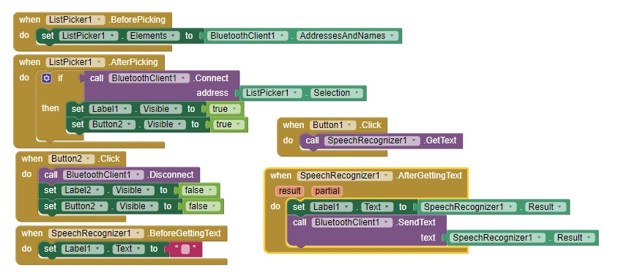

**ANDROID APPLICATION FOR HARDWARE:**

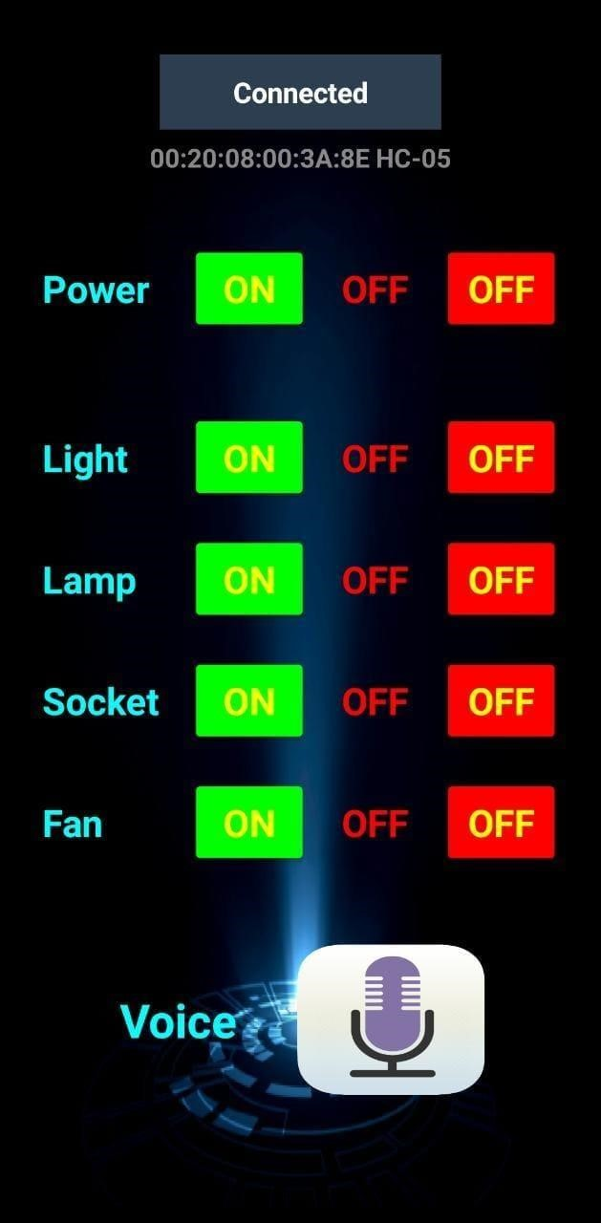

* The is created on MIT APP INVENTOR an online platform to develop android apps.
* For the hardware module according to the requirements the app is designed. • We have to connect the App to the HC – 05 Bluetooth Module that acts as the communication protocol.
* We have added two features to operate the appliances either manually through the buttons that are enabled or through the voice command.

**CODE:**

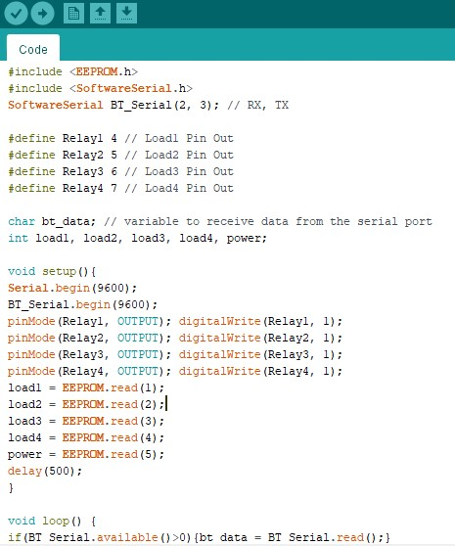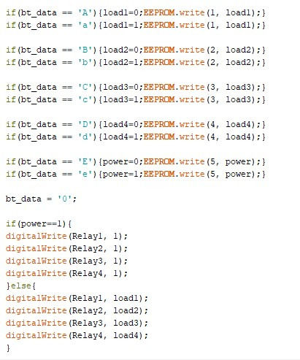

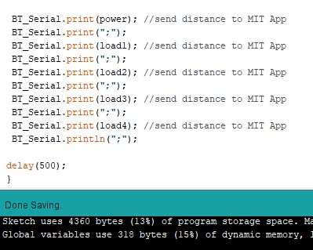

**BLOCKS FOR ANDROID APP:**

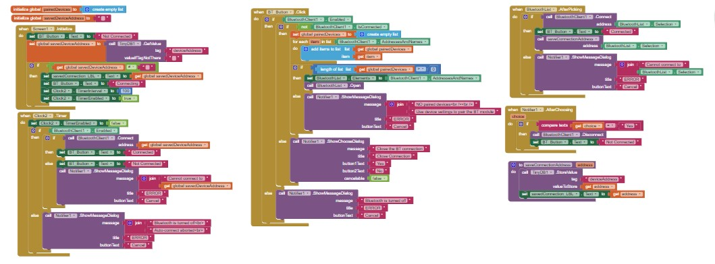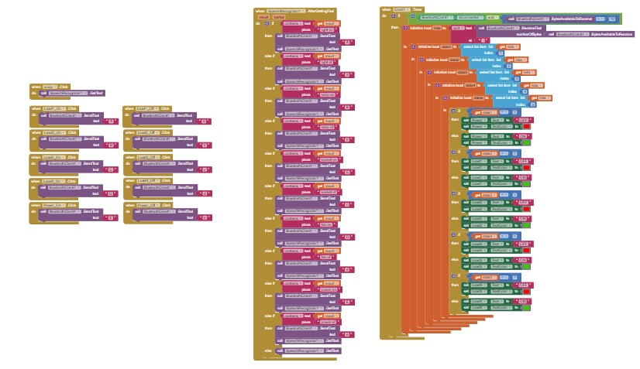

**DEMONSTRATION:**

* **TURN ON LIGHT**(The relay connected to the light gets closed and the light bulb glows)

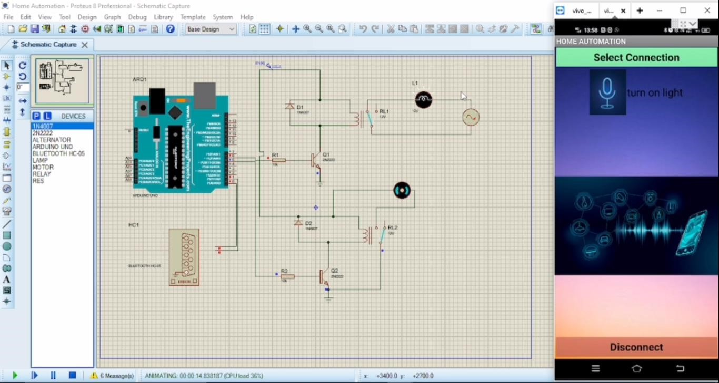

* **TURN ON FAN** (The relay connected to the fan gets closed and the fan rotates)

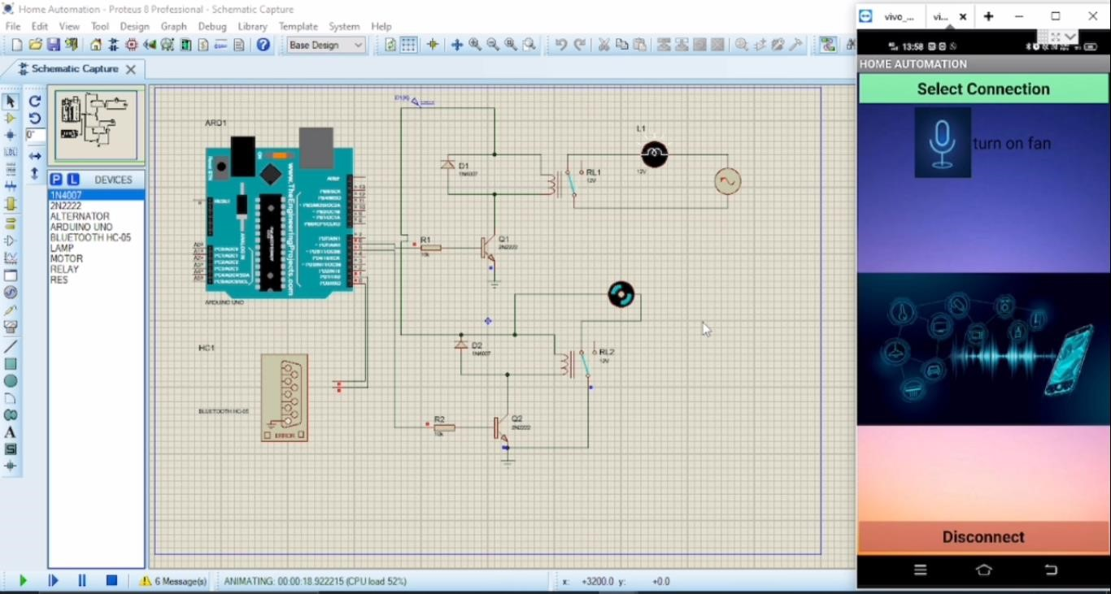

* **TURN OFF ALL**(The relay connected to the light and fan gets opened so the light bulb stops to glow and the fan stops to rotate)

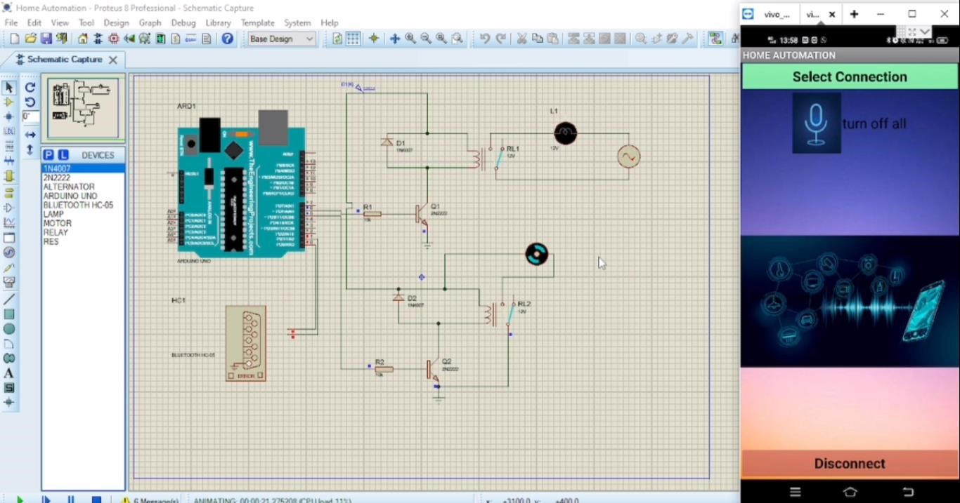

* **TURN ON ALL**(The relay connected to the light and fan gets closed so the light bulb starts to glow and the fan starts to rotate)

